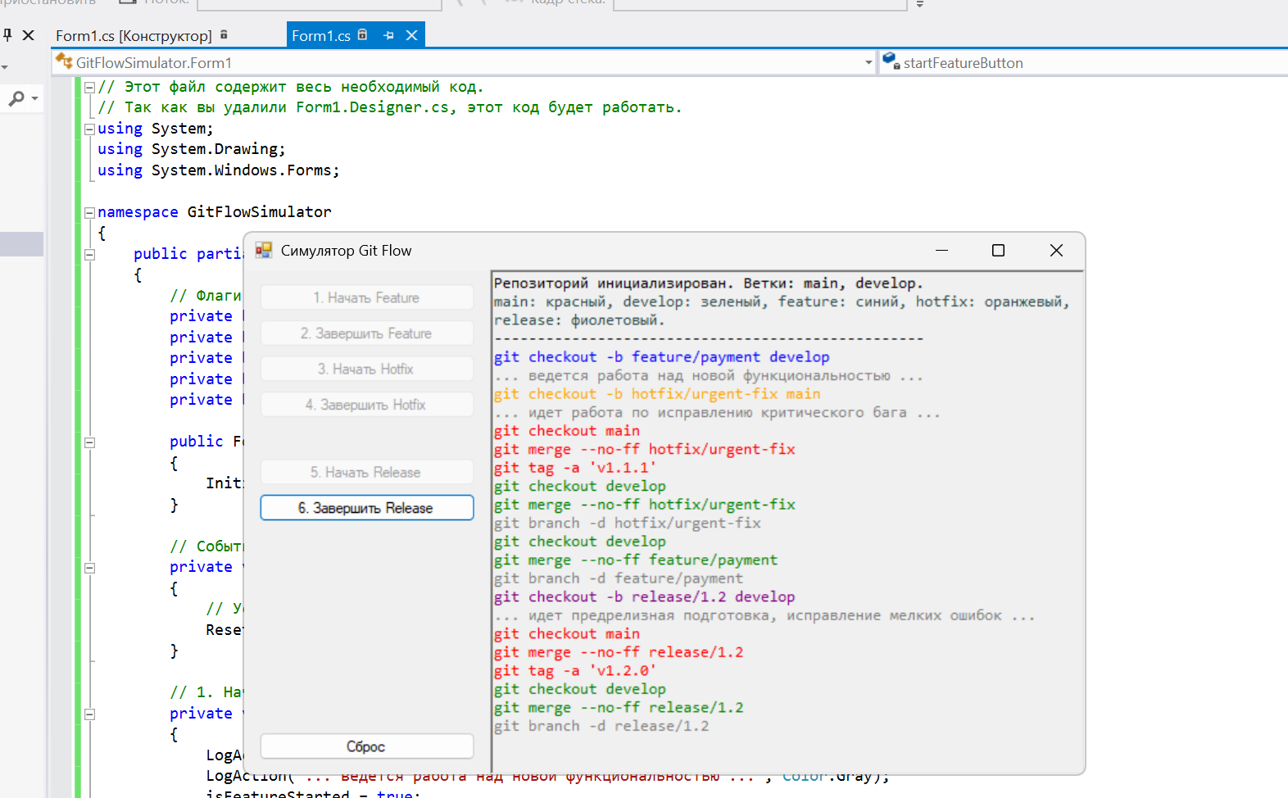

Код using System;

using System.Drawing;

using System.Windows.Forms;

namespace GitFlowSimulator

{

public partial class Form1 : Form

{

private bool isFeatureStarted = false;

private bool isFeatureFinished = false;

private bool isHotfixStarted = false;

private bool isHotfixFinished = false;

private bool isReleaseStarted = false;

public Form1()

{

InitializeComponent();

}

private void Form1_Load(object sender, EventArgs e)

{

ResetState();

}

private void startFeatureButton_Click(object sender, EventArgs e)

{

LogAction("git checkout -b feature/payment develop", Color.Blue);

LogAction("... ведется работа над новой функциональностью ...", Color.Gray);

isFeatureStarted = true;

UpdateUIState();

}

private void finishFeatureButton_Click(object sender, EventArgs e)

{

LogAction("git checkout develop", Color.Green);

LogAction("git merge --no-ff feature/payment", Color.Green);

LogAction("git branch -d feature/payment", Color.Gray);

isFeatureFinished = true;

UpdateUIState();

}

private void startHotfixButton_Click(object sender, EventArgs e)

{

LogAction("git checkout -b hotfix/urgent-fix main", Color.Orange);

LogAction("... идет работа по исправлению критического бага ...", Color.Gray);

isHotfixStarted = true;

UpdateUIState();

}

private void finishHotfixButton_Click(object sender, EventArgs e)

{

LogAction("git checkout main", Color.Red);

LogAction("git merge --no-ff hotfix/urgent-fix", Color.Red);

LogAction("git tag -a 'v1.1.1'", Color.Red);

LogAction("git checkout develop", Color.Green);

LogAction("git merge --no-ff hotfix/urgent-fix", Color.Green);

LogAction("git branch -d hotfix/urgent-fix", Color.Gray);

isHotfixFinished = true;

UpdateUIState();

}

private void startReleaseButton_Click(object sender, EventArgs e)

{

LogAction("git checkout -b release/1.2 develop", Color.Purple);

LogAction("... идет предрелизная подготовка, исправление мелких ошибок ...", Color.Gray);

isReleaseStarted = true;

UpdateUIState();

}

private void finishReleaseButton_Click(object sender, EventArgs e)

{

LogAction("git checkout main", Color.Red);

LogAction("git merge --no-ff release/1.2", Color.Red);

LogAction("git tag -a 'v1.2.0'", Color.Red);

LogAction("git checkout develop", Color.Green);

LogAction("git merge --no-ff release/1.2", Color.Green);

LogAction("git branch -d release/1.2", Color.Gray);

UpdateUIState();

}

private void resetButton_Click(object sender, EventArgs e)

{

ResetState();

}

/// <summary>

/// </summary>

private void ResetState()

{

logTextBox.Clear();

LogAction("Репозиторий инициализирован. Ветки: main, develop.", Color.Black);

LogAction("main: красный, develop: зеленый, feature: синий, hotfix: оранжевый, release: фиолетовый.", Color.DarkSlateGray);

logTextBox.AppendText("--------------------------------------------------\n");

isFeatureStarted = false;

isFeatureFinished = false;

isHotfixStarted = false;

isHotfixFinished = false;

isReleaseStarted = false;

UpdateUIState();

}

/// <summary>

/// </summary>

private void UpdateUIState()

{

startFeatureButton.Enabled = !isFeatureStarted;

finishFeatureButton.Enabled = isFeatureStarted && !isFeatureFinished;

startHotfixButton.Enabled = !isHotfixStarted;

finishHotfixButton.Enabled = isHotfixStarted && !isHotfixFinished;

startReleaseButton.Enabled = isFeatureFinished && !isReleaseStarted;

finishReleaseButton.Enabled = isReleaseStarted;

}

/// <summary>

/// </summary>

private void LogAction(string message, Color color)

{

logTextBox.SelectionStart = logTextBox.TextLength;

logTextBox.SelectionLength = 0;

logTextBox.SelectionColor = color;

logTextBox.AppendText(message + Environment.NewLine);

logTextBox.SelectionColor = logTextBox.ForeColor;

logTextBox.ScrollToCaret();

}

#region Windows Form Designer generated code

/// <summary>

/// </summary>

private System.ComponentModel.IContainer components = null;

/// <summary>

/// </summary>

/// <param name="disposing">.</param>

protected override void Dispose(bool disposing)

{

if (disposing && (components != null))

{

components.Dispose();

}

base.Dispose(disposing);

}

/// <summary>

/// </summary>

private void InitializeComponent()

{

this.logTextBox = new System.Windows.Forms.RichTextBox();

this.buttonsPanel = new System.Windows.Forms.Panel();

this.resetButton = new System.Windows.Forms.Button();

this.finishReleaseButton = new System.Windows.Forms.Button();

this.startReleaseButton = new System.Windows.Forms.Button();

this.finishHotfixButton = new System.Windows.Forms.Button();

this.startHotfixButton = new System.Windows.Forms.Button();

this.finishFeatureButton = new System.Windows.Forms.Button();

this.startFeatureButton = new System.Windows.Forms.Button();

this.buttonsPanel.SuspendLayout();

this.SuspendLayout();

//

//

this.logTextBox.Dock = System.Windows.Forms.DockStyle.Fill;

this.logTextBox.Font = new System.Drawing.Font("Consolas", 9.75F, System.Drawing.FontStyle.Regular, System.Drawing.GraphicsUnit.Point, ((byte)(204)));

this.logTextBox.Location = new System.Drawing.Point(200, 0);

this.logTextBox.Name = "logTextBox";

this.logTextBox.ReadOnly = true;

this.logTextBox.Size = new System.Drawing.Size(484, 411);

this.logTextBox.TabIndex = 0;

this.logTextBox.Text = "";

//

//

this.buttonsPanel.Controls.Add(this.resetButton);

this.buttonsPanel.Controls.Add(this.finishReleaseButton);

this.buttonsPanel.Controls.Add(this.startReleaseButton);

this.buttonsPanel.Controls.Add(this.finishHotfixButton);

this.buttonsPanel.Controls.Add(this.startHotfixButton);

this.buttonsPanel.Controls.Add(this.finishFeatureButton);

this.buttonsPanel.Controls.Add(this.startFeatureButton);

this.buttonsPanel.Dock = System.Windows.Forms.DockStyle.Left;

this.buttonsPanel.Location = new System.Drawing.Point(0, 0);

this.buttonsPanel.Name = "buttonsPanel";

this.buttonsPanel.Size = new System.Drawing.Size(200, 411);

this.buttonsPanel.TabIndex = 1;

//

//

this.resetButton.Location = new System.Drawing.Point(12, 376);

this.resetButton.Name = "resetButton";

this.resetButton.Size = new System.Drawing.Size(176, 23);

this.resetButton.TabIndex = 6;

this.resetButton.Text = "Сброс";

this.resetButton.UseVisualStyleBackColor = true;

this.resetButton.Click += new System.EventHandler(this.resetButton_Click);

//

//

this.finishReleaseButton.Location = new System.Drawing.Point(12, 182);

this.finishReleaseButton.Name = "finishReleaseButton";

this.finishReleaseButton.Size = new System.Drawing.Size(176, 23);

this.finishReleaseButton.TabIndex = 5;

this.finishReleaseButton.Text = "6. Завершить Release";

this.finishReleaseButton.UseVisualStyleBackColor = true;

this.finishReleaseButton.Click += new System.EventHandler(this.finishReleaseButton_Click);

//

//

this.startReleaseButton.Location = new System.Drawing.Point(12, 153);

this.startReleaseButton.Name = "startReleaseButton";

this.startReleaseButton.Size = new System.Drawing.Size(176, 23);

this.startReleaseButton.TabIndex = 4;

this.startReleaseButton.Text = "5. Начать Release";

this.startReleaseButton.UseVisualStyleBackColor = true;

this.startReleaseButton.Click += new System.EventHandler(this.startReleaseButton_Click);

//

//

this.finishHotfixButton.Location = new System.Drawing.Point(12, 98);

this.finishHotfixButton.Name = "finishHotfixButton";

this.finishHotfixButton.Size = new System.Drawing.Size(176, 23);

this.finishHotfixButton.TabIndex = 3;

this.finishHotfixButton.Text = "4. Завершить Hotfix";

this.finishHotfixButton.UseVisualStyleBackColor = true;

this.finishHotfixButton.Click += new System.EventHandler(this.finishHotfixButton_Click);

//

//

this.startHotfixButton.Location = new System.Drawing.Point(12, 69);

this.startHotfixButton.Name = "startHotfixButton";

this.startHotfixButton.Size = new System.Drawing.Size(176, 23);

this.startHotfixButton.TabIndex = 2;

this.startHotfixButton.Text = "3. Начать Hotfix";

this.startHotfixButton.UseVisualStyleBackColor = true;

this.startHotfixButton.Click += new System.EventHandler(this.startHotfixButton_Click);

//

//

this.finishFeatureButton.Location = new System.Drawing.Point(12, 40);

this.finishFeatureButton.Name = "finishFeatureButton";

this.finishFeatureButton.Size = new System.Drawing.Size(176, 23);

this.finishFeatureButton.TabIndex = 1;

this.finishFeatureButton.Text = "2. Завершить Feature";

this.finishFeatureButton.UseVisualStyleBackColor = true;

this.finishFeatureButton.Click += new System.EventHandler(this.finishFeatureButton_Click);

//

//

this.startFeatureButton.Location = new System.Drawing.Point(12, 11);

this.startFeatureButton.Name = "startFeatureButton";

this.startFeatureButton.Size = new System.Drawing.Size(176, 23);

this.startFeatureButton.TabIndex = 0;

this.startFeatureButton.Text = "1. Начать Feature";

this.startFeatureButton.UseVisualStyleBackColor = true;

this.startFeatureButton.Click += new System.EventHandler(this.startFeatureButton_Click);

//

// Form1

//

this.AutoScaleDimensions = new System.Drawing.SizeF(6F, 13F);

this.AutoScaleMode = System.Windows.Forms.AutoScaleMode.Font;

this.ClientSize = new System.Drawing.Size(684, 411);

this.Controls.Add(this.logTextBox);

this.Controls.Add(this.buttonsPanel);

this.FormBorderStyle = System.Windows.Forms.FormBorderStyle.FixedSingle;

this.Name = "Form1";

this.StartPosition = System.Windows.Forms.FormStartPosition.CenterScreen;

this.Text = "Симулятор Git Flow";

this.Load += new System.EventHandler(this.Form1_Load);

this.buttonsPanel.ResumeLayout(false);

this.ResumeLayout(false);

}

#endregion

private System.Windows.Forms.RichTextBox logTextBox;

private System.Windows.Forms.Panel buttonsPanel;

private System.Windows.Forms.Button resetButton;

private System.Windows.Forms.Button finishReleaseButton;

private System.Windows.Forms.Button startReleaseButton;

private System.Windows.Forms.Button finishHotfixButton;

private System.Windows.Forms.Button startHotfixButton;

private System.Windows.Forms.Button finishFeatureButton;

private System.Windows.Forms.Button startFeatureButton;

}

}